|  |  |
| --- | --- |
| **Project – External Document** |  |
| COMP6681001  Web Programming |
| Odd Semester Year 2022/2023 |

* Project Title

MaiBoutique

* Introduction

This project is about creating a boutique shop website using Laravel Framework, PHP, and MySQL. MySQL, MVC concept and Eloquent Query are implemented for the database. There are 2 user roles, member and admin. Each role has features that only they can access. Middleware is used to make sure that users can only access pages according to their role.

* Report / Documentation

1. This is the Welcome page. Users can click “Sign In” or “Sign up” to go to the respective page.

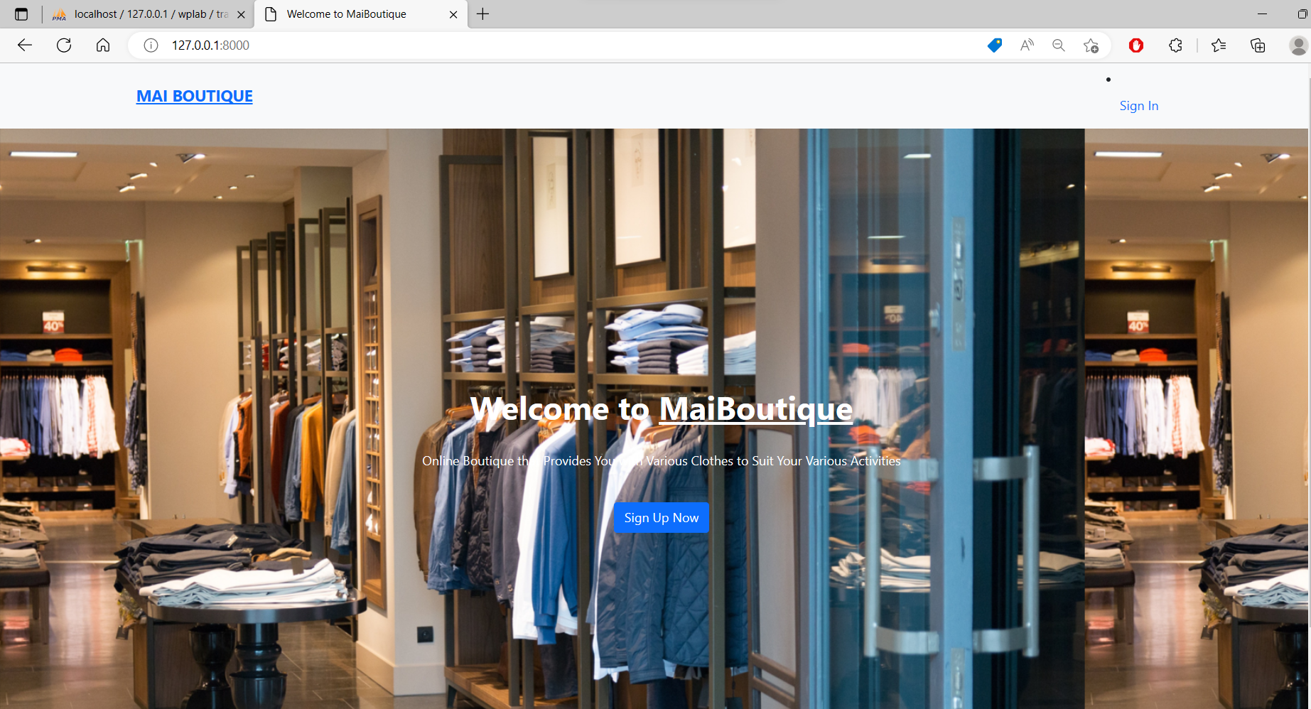

1. This is the Sign Up page. Users can enter their username, email, password, phone number and address. Once they click submit, their account will be created, and they will be redirected to the home page. Users can also go to the Sign In page. 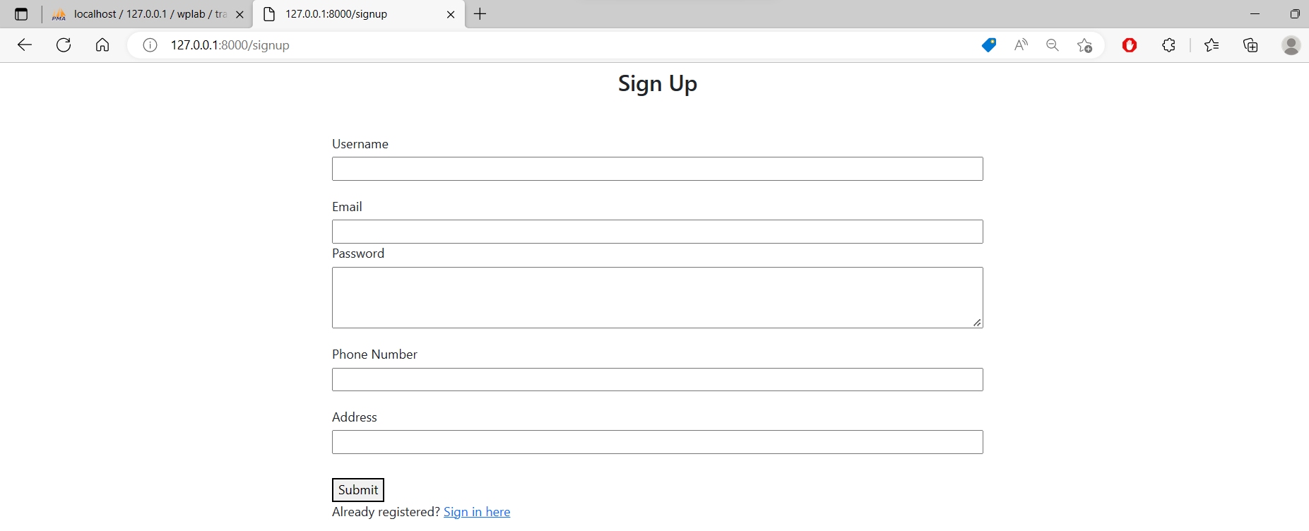

Each field have their own requirements. Not fulfilling them will result in an error message. Submitting an empty field will also do the same.

There are 2 accounts by default.



A new account has been registered successfully.



1. This is the Sign In page. Users can sign in using their registered account by entering their email and password, then clicking “Login”. Users can also check the “Remember me” box to save cookies. Users can also go to the Sign Up page. If the fields are empty or the email/password is wrong, an error message will be sent out.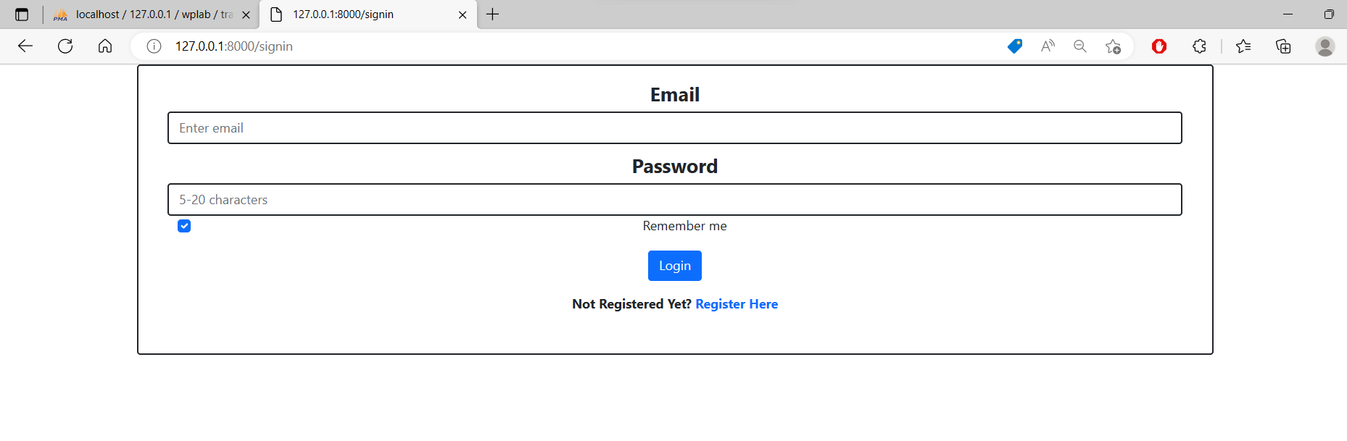 Cookies have been successfully saved when signing in using member@maiboutique.com. 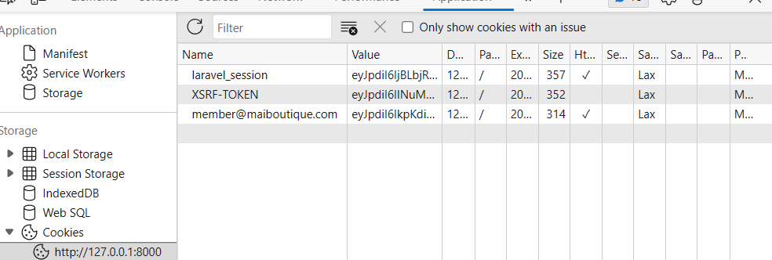
2. This is the Home page. Users can see all products sold. The products are shown in groups of eight by pagination. Users can go to the next page of products by clicking the pagination link below. Users can view a product’s details by clicking “More Details”. The navbar shown will be different based on the user’s role. 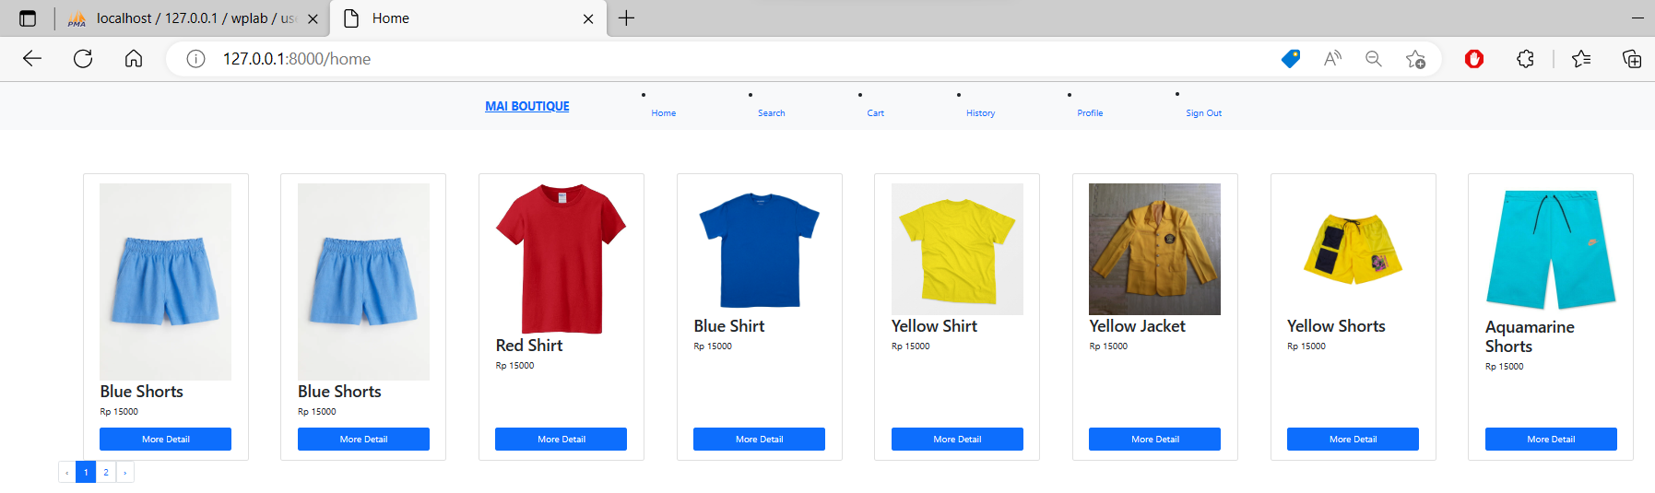The page above is for members. It has the “Cart” and “History” button. 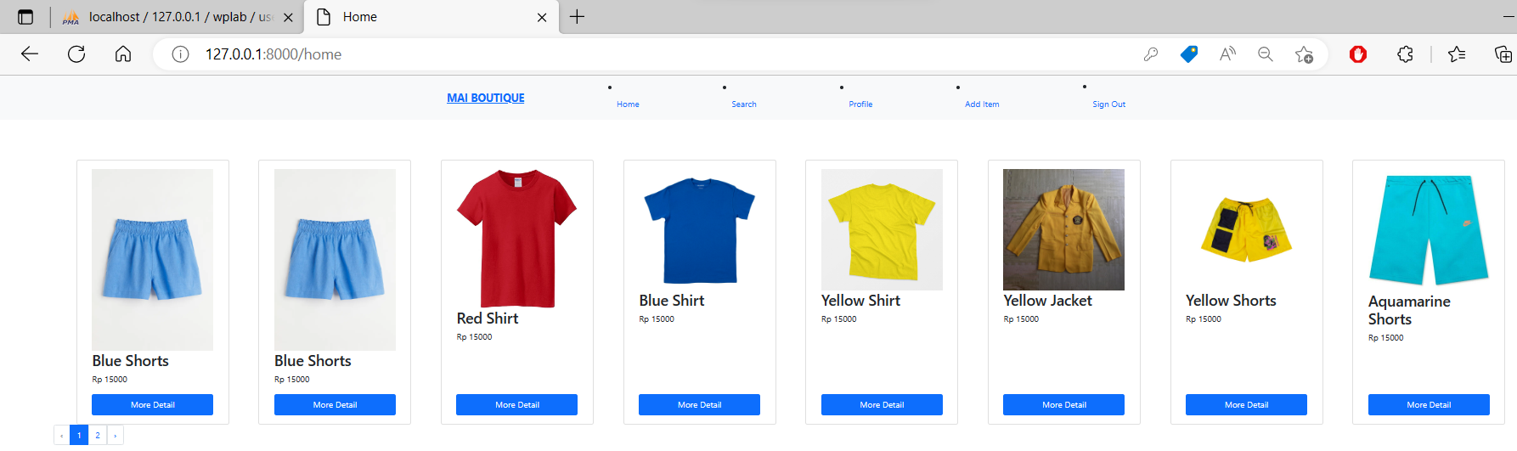The page above is for admins. It has the “Add Item” button, but not “Cart” nor “History”. Other buttons are accessible by other roles.
3. This is the Product Detail page. Users can see additional information of the selected product. The options shown are different for members and admins. 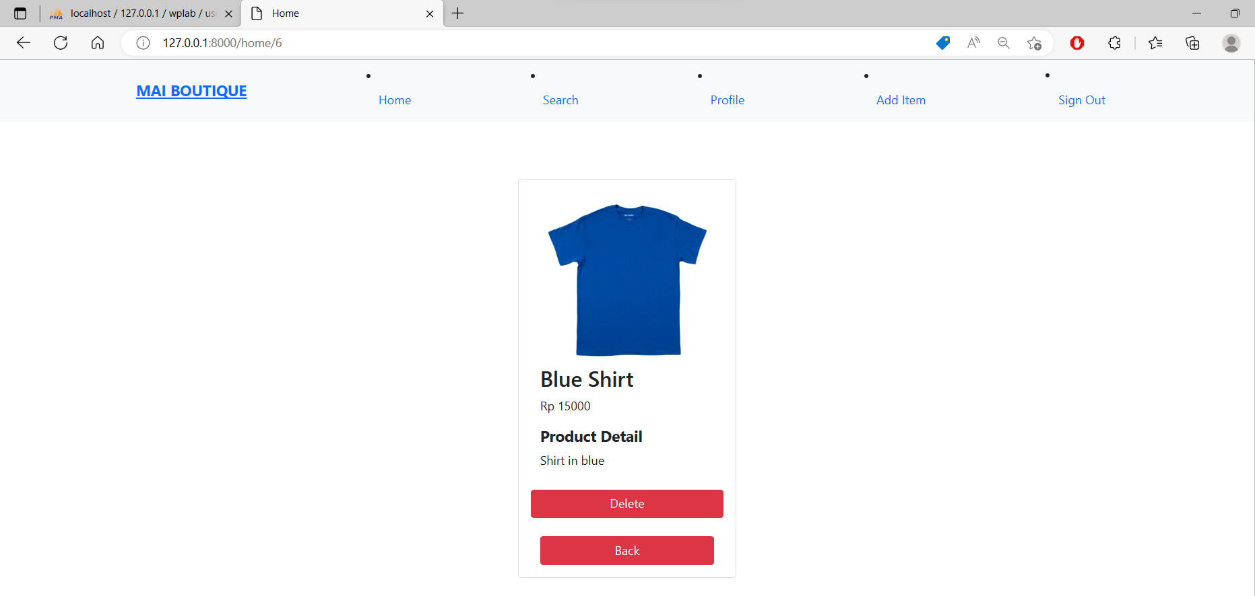This is the Product Detail page for admins. Admins can delete the item from the website.

Blue Shirt has been successfully deleted from the website.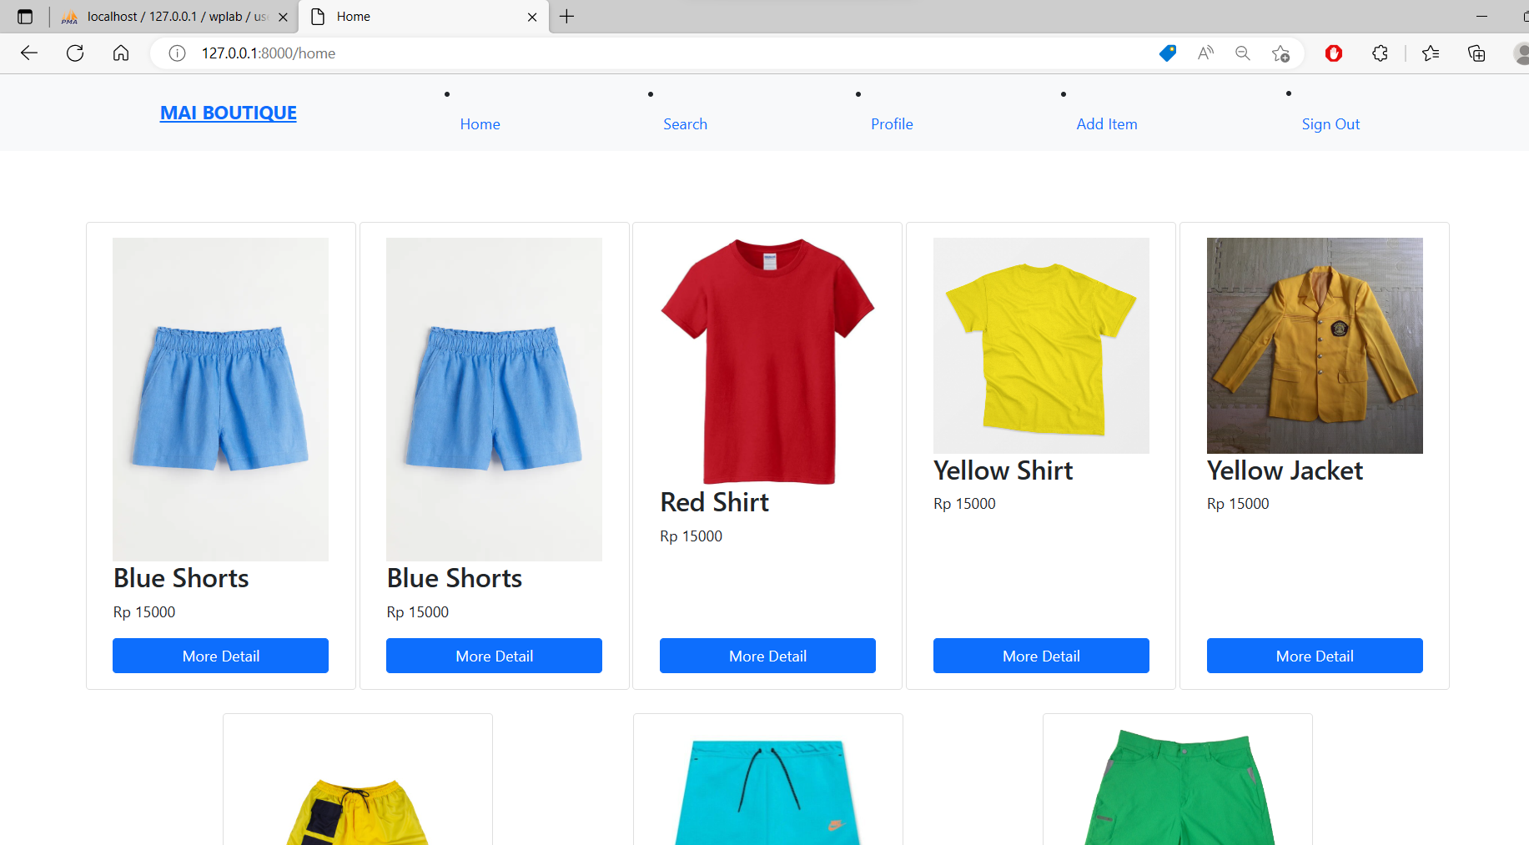

Below is the Product Detail page for members. Members can add the product and its quantity to the cart. 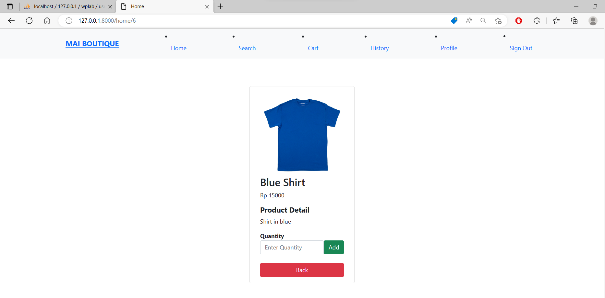

1. This is the View Profile Page. Users can see their profile information. Members can edit their profile and password, while admins can only edit their password.

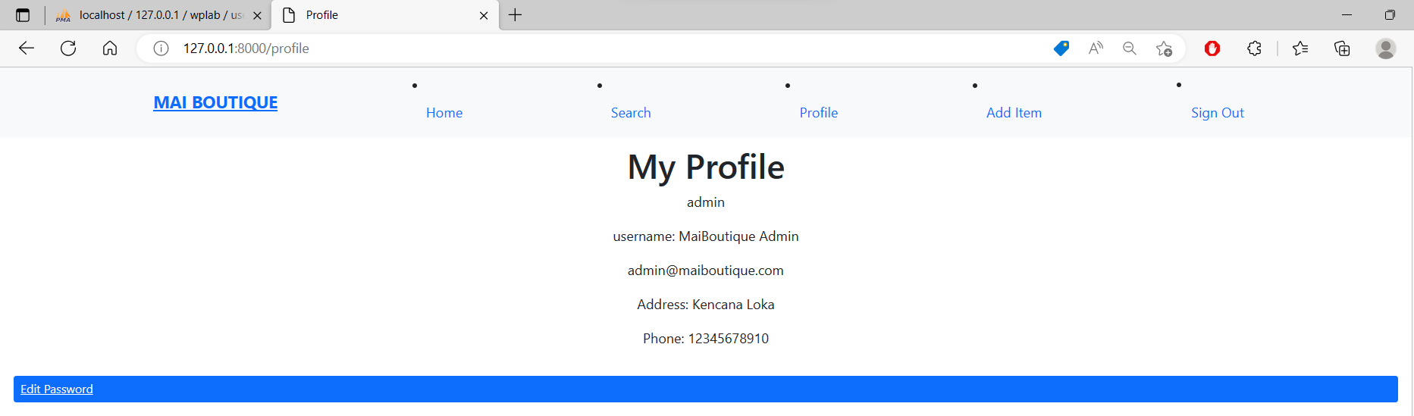

Above is the View Profile Page for admins.

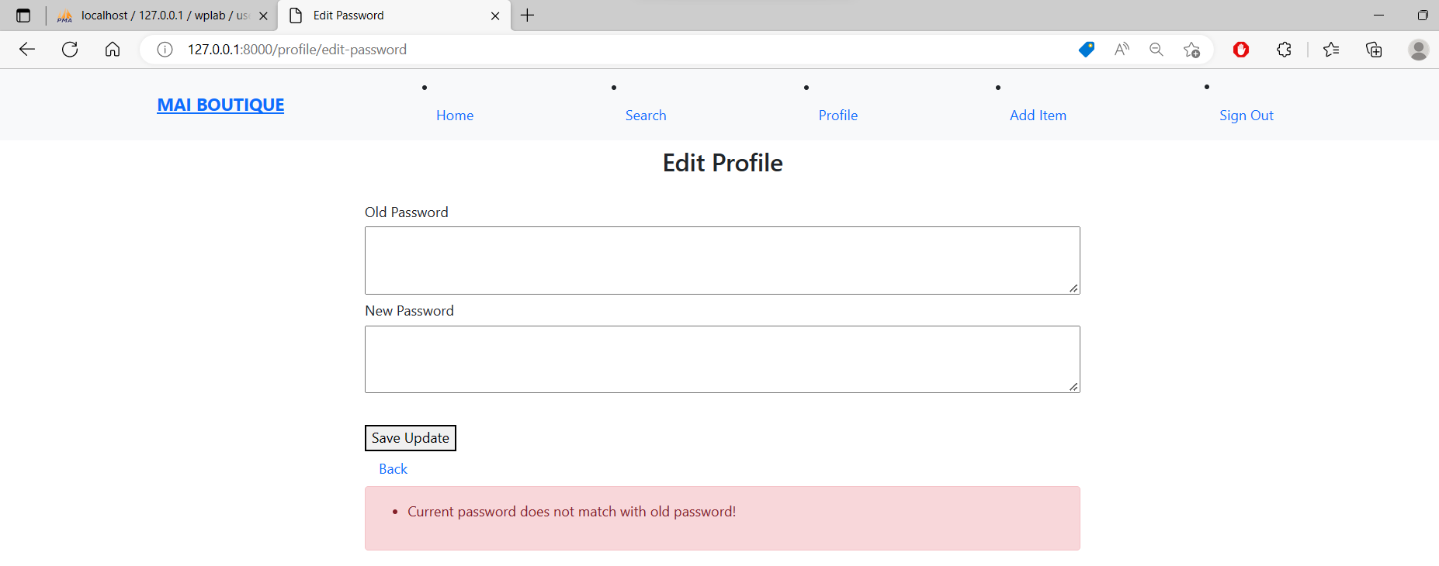

When changing passwords, users must enter their current password. If it is incorrect, then it will fail and send out an error message. An error message will also be sent out if an empty field is submitted or if the new password is too short.

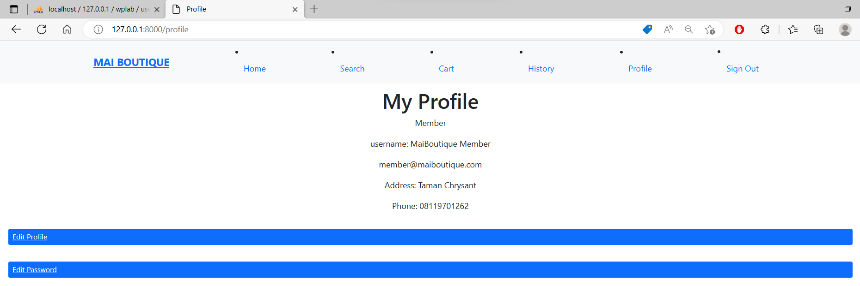

Above is the View Profile page for members. Members can edit their profile. If the fields requirements are not fulfilled, there will be an error message.

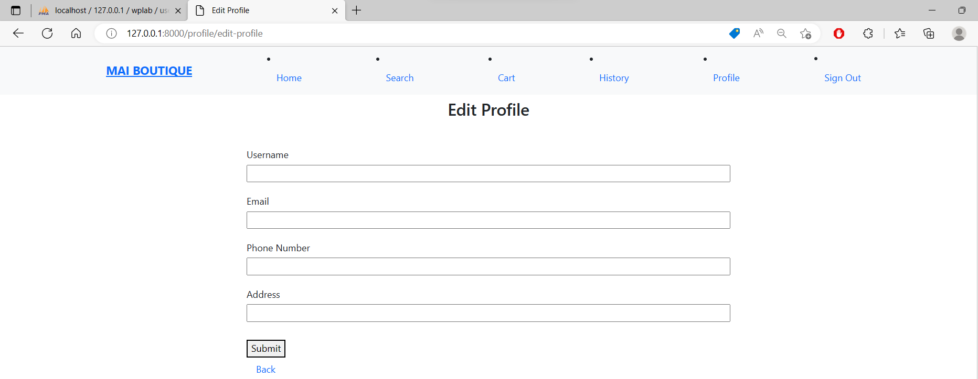

Profile has been successfully updated.

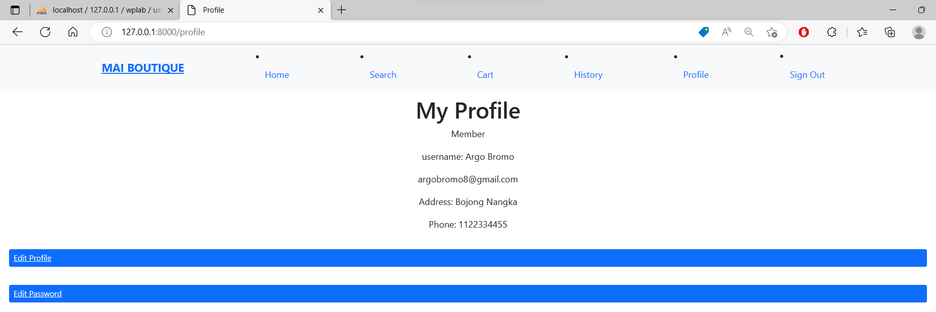

1. This is the Add Item page. This page is only accessible for admins. Validation is done for this form as well. Uploaded images are stored in public/assets.

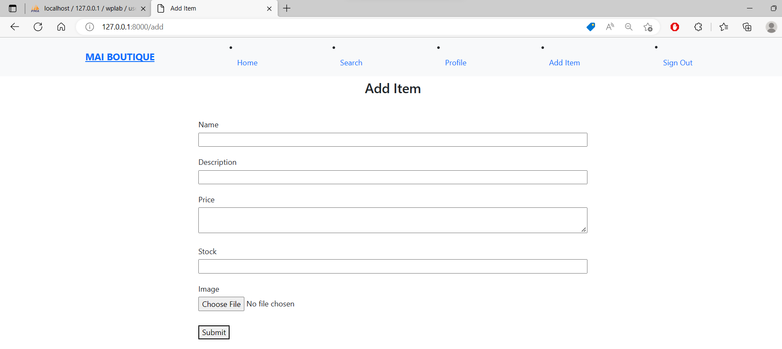

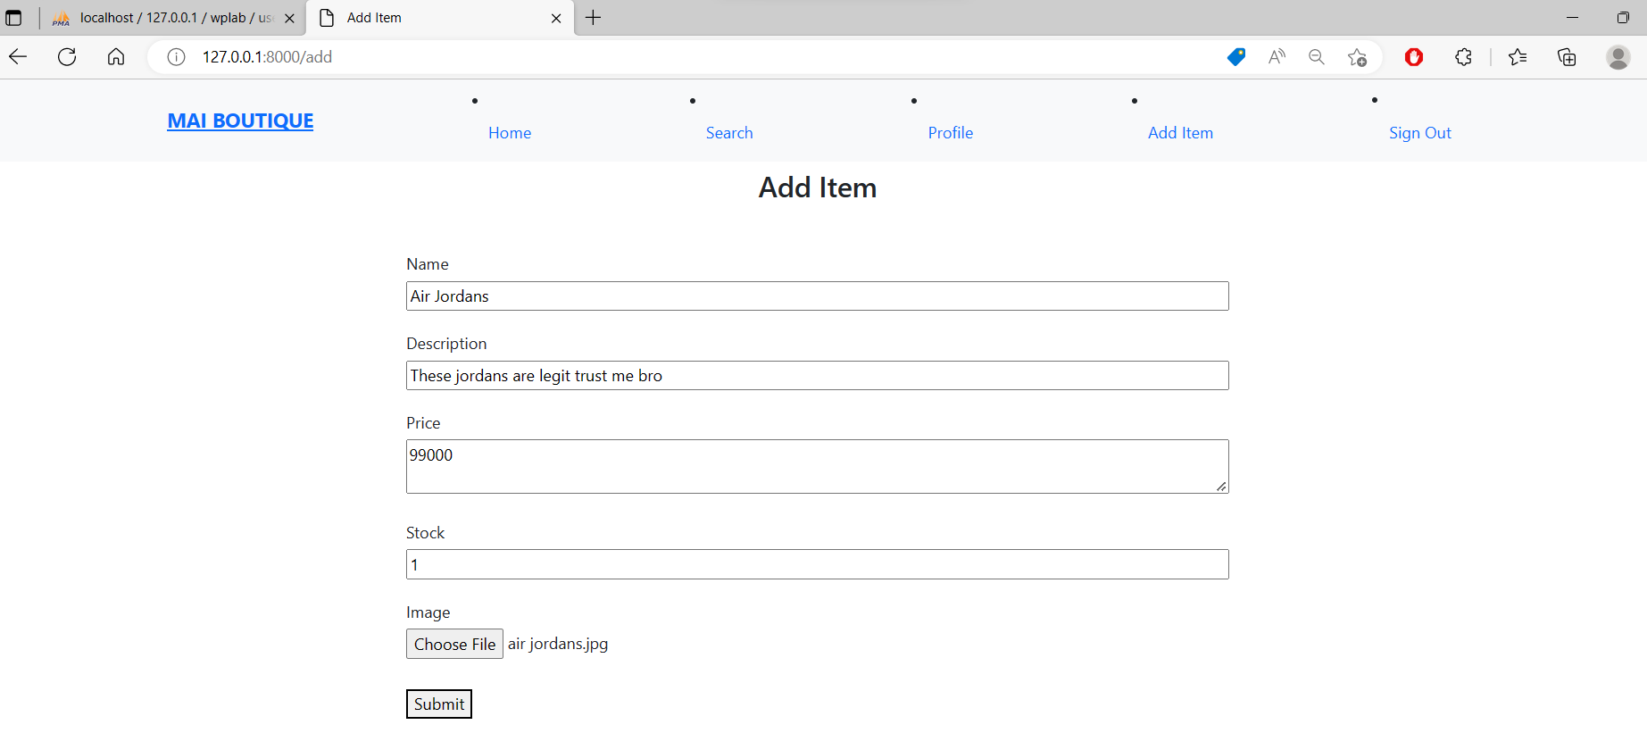 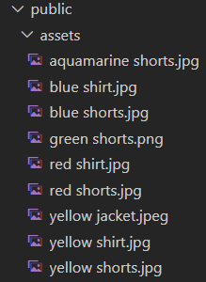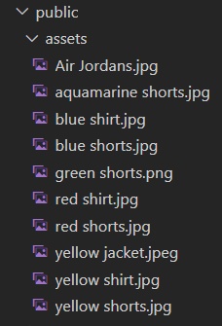

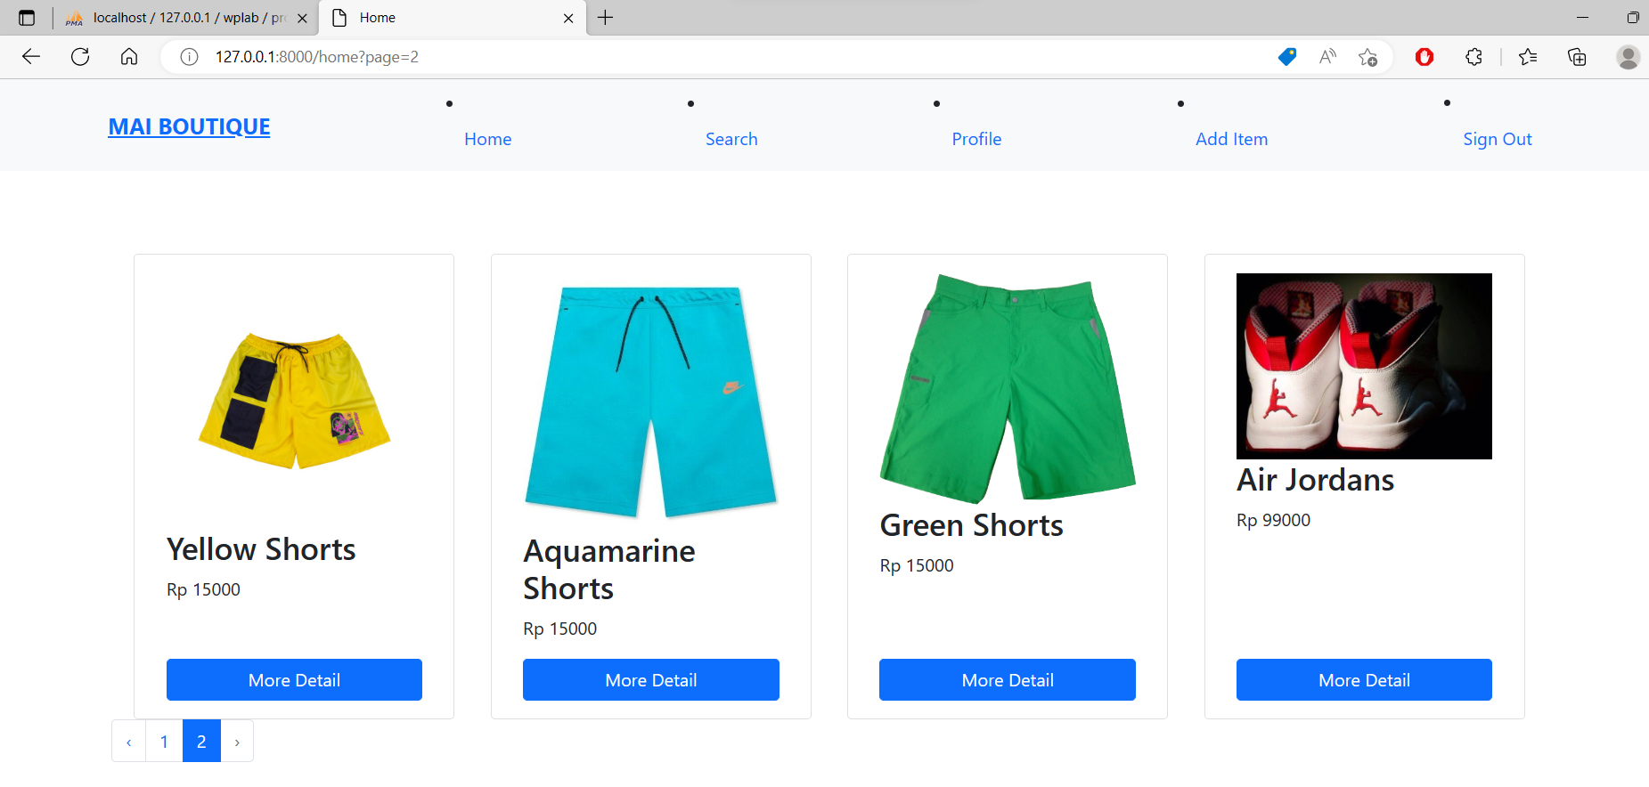

New product successfully added.

1. This is the Search page. Search for “shirt”. There are 3 results.

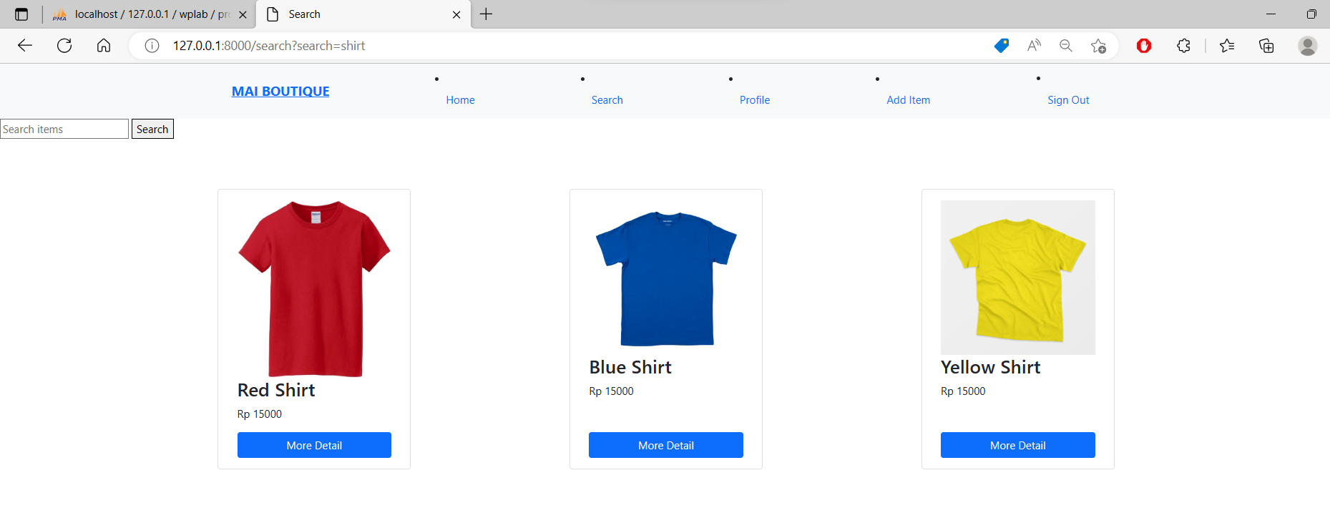

Search for “yellow”. There are 3 results. Pagination only applies when there are at least 8 results.

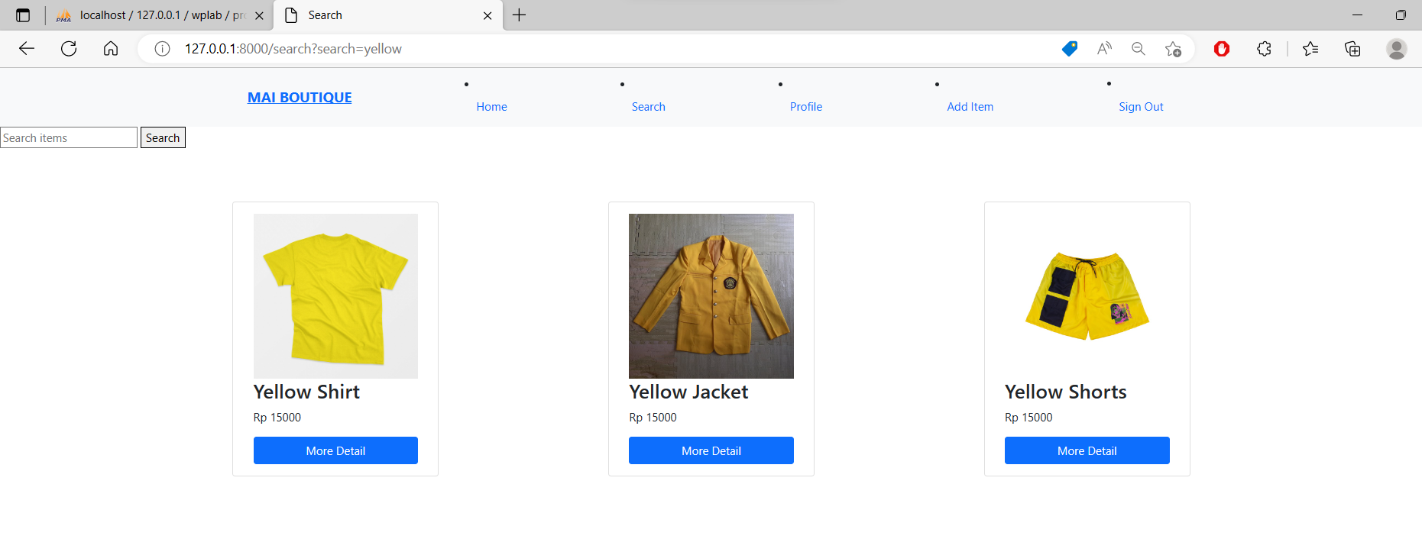

1. As for Cart and History, we have not managed to do exactly as requested because we had difficulties with placing items in the Cart page.

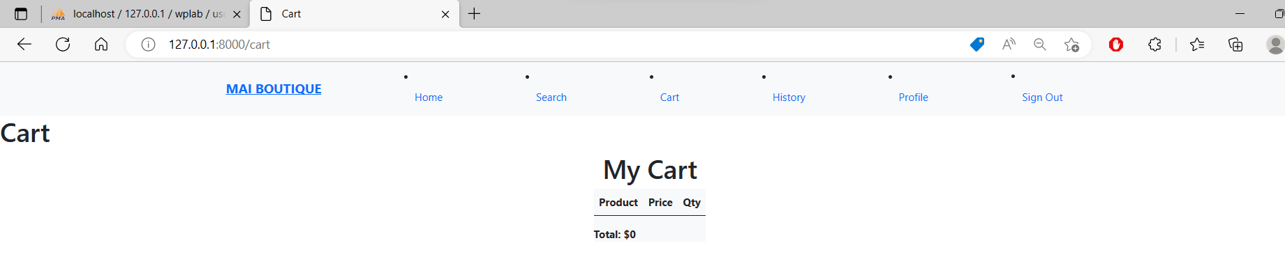

One approach that was used is javascript. The javascript is functioning as an event handlers, so when the user wanted to choose the add button to the cart page, the handler would update the cart.



1. Middleware works as intended. The below page appears when trying to access the Add Item page as a non-admin.

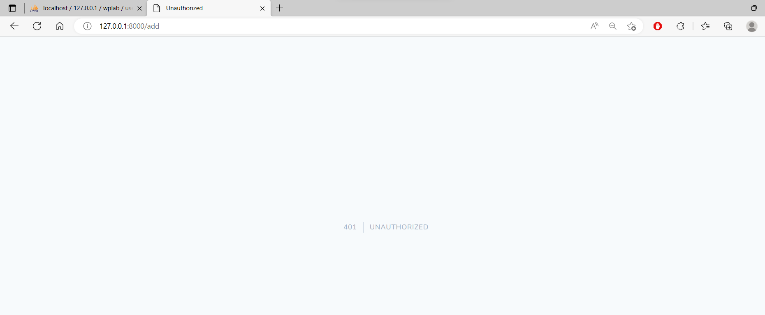

There are three middlewares used, AuthCheck, MemberCheck, and AdminCheck. AuthCheck makes sure that the user is logged in, while the other two authorizes access for the two roles. The three middlewares are declared in routeMiddleware.

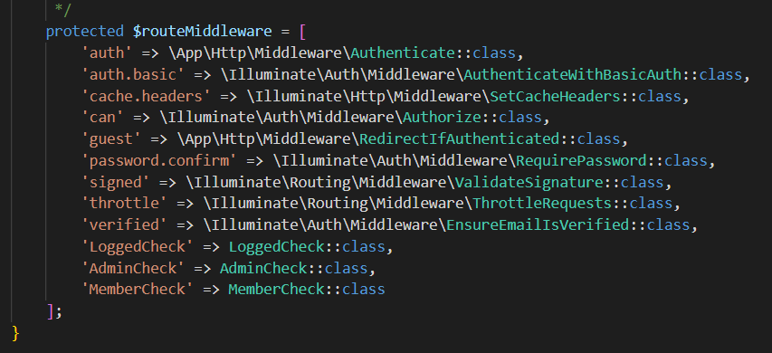

The grouping of routes and the middleware can be seen below.

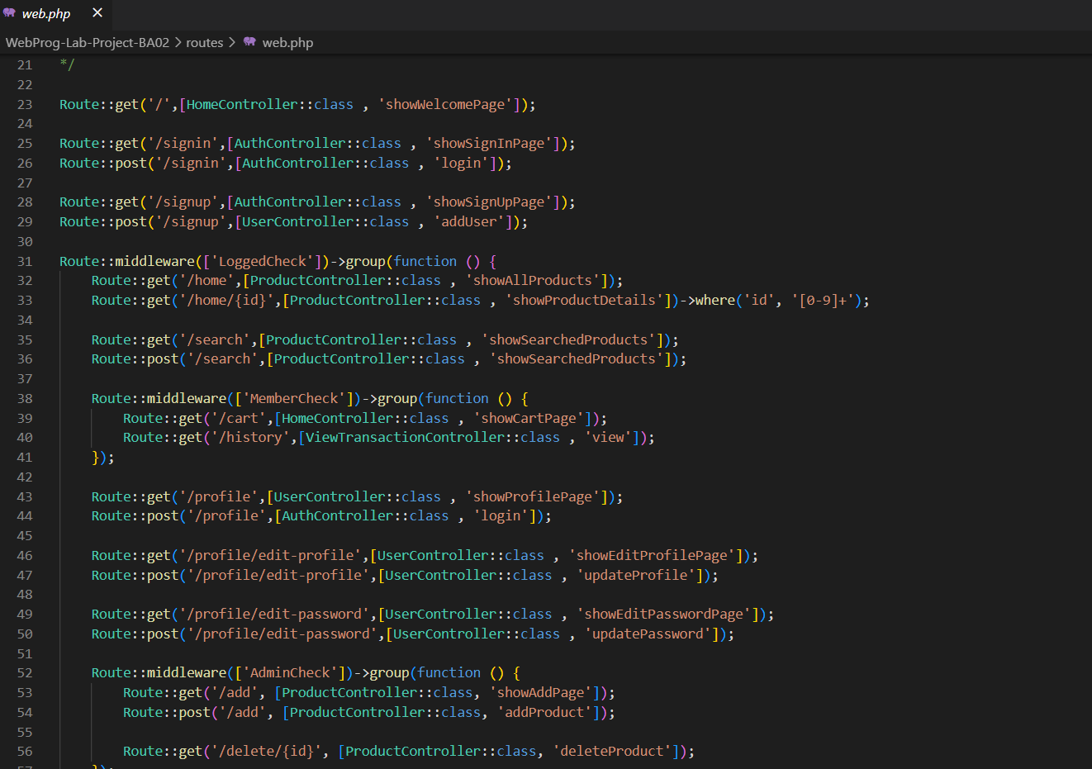

* Reference
* <https://s2.bukalapak.com/img/24378240452/large/data.jpeg>
* <https://www.nicepng.com/png/full/366-3664639_quick-view-green-shorts-png.png>
* <https://i.ebayimg.com/images/g/cgQAAOSwtjBhIzgR/s-l640.jpg>
* <https://images.tokopedia.net/img/cache/700/hDjmkQ/2022/1/12/44c6f040-9796-4776-9412-ec841639a419.jpg>
* <https://imgprd19.hobbylobby.com/f/ce/1d/fce1d14059fb3f8abd333889ad07ea611c4f8b4e/1400Wx1400H-1013705-0320.jpg>
* <https://cf.shopee.co.id/file/840aaaa1571ee026714ee3bfcaff2711>
* <https://lp2.hm.com/hmgoepprod?set=format%5Bwebp%5D%2Cquality%5B79%5D%2Csource%5B%2Fd9%2Fbb%2Fd9bbeb60f6e081034f7f935e62ef24697ebc07a1.jpg%5D%2Corigin%5Bdam%5D%2Ccategory%5B%5D%2Ctype%5BDESCRIPTIVESTILLLIFE%5D%2Cres%5Bm%5D%2Chmver%5B2%5D&call=url%5Bfile%3A%2Fproduct%2Fmain%5D>
* <https://images-cdn.ubuy.co.id/6360255ffcde3661332b61a9-gildan-blank-t-shirt-unisex-style-5000.jpg>
* <https://cf.shopee.co.id/file/5ff25e3f75447dbe73057ff2d9a659bf>
* <https://pbs.twimg.com/media/Bg2m3UYCUAA5aXz.jpg:large>
* Group Member
* 2440016672 – Javier Islamey
* 2440011463 – Charles Wilbert